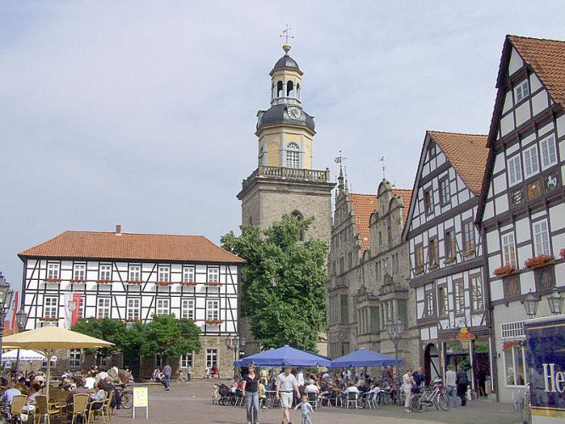
W E S T E R N U N I V E R S I T Y
Department of Languages and Cultures

German 1030: German for Beginners
2023 – 2024
Course Instructor: Adrian Mioc (amioc2@uwo.ca)
(Office hours: Tu 1:30-3:30 PM UC 3314)
Section 1: M/W 1:30-3:30 PM
Section 2: Tu/Th 11:30-1:30 PM
Section 3: Tu/Th 3:30-5:30 PM
Practice speaking, understanding, reading and writing German in a dynamic class setting. Begin to develop your communicative and intercultural skills while learning interesting and useful things about the German-speaking countries.

Course Content and Aims:
German 1030 is an introductory course designed for students with little or no prior knowledge of German. The course is structured to link language instruction to a general understanding of life in the German-speaking countries. German for Beginners concentrates on high-frequency vocabulary and basic grammar. Students learn to use the language through active classroom participation, homework assignments, and independent work with online resources. Many aspects of German culture will be introduced through authentic materials including short films, ads, songs etc.
Successful students may progress to German 2200 (Intermediate German) next year, as well as to the German modules offered at Western. Students with Grade 12U German or equivalent language skills will normally take German 2200 right away and must consult the department before registering in German 1030. If you already speak some German, please consult the course coordinator or your instructor.

Contact Hours: 2 two-hour class meetings per week. Attendance is mandatory.

Text: (available at the Western Book Store)

Required: Treffpunkt Deutsch 7th edition bundle with MyGermanLab access
*This value-pack bundle contains the Treffpunkt Deutsch 7th edition loose-leaf textbook and an online access code to MyGermanLab. MyGermanLab also includes an e-textbook, so some students may want to purchase only multi-semester MyGermanLab access (available online). This is fine, but will not result in substantial savings. Students need to bring the textbook (or e-textbook) to every class. Access to MyGermanLab is required for all students to complete online assignments and other activities.

Recommended: English Grammar for Students of German
*Not everybody needs this book, but many students, especially those who are “grammatically challenged”, have found it very useful. If you tend to feel confused about grammar you should pick it up. Most students are fine with just the regular course package.
Mark Breakdown:
Active participation in class 10 %
Online assignments (2 x 5%) 10 %
Two short writing assignments (2 x 4%) 8 %
One oral assessment 7 %
Seven short chapter tests (7 x 5%) 35 %
Final exam 30 %

Learning a language is an enjoyable and rewarding long-term project and requires an ongoing commitment.
Review what you have learned after each class and complete the homework your instructor assigns. The online activities on MyGermanLab are designed to reinforce new vocabulary and structures, so work on these exercises as often as possible and complete them by their due dates.

Learning Outcomes:
It is expected that upon successful completion of this course, students will be able to do the following:
- Pronounce German correctly
- understand German when spoken slowly and clearly, using familiar words and phrases
- understand short, relatively simple texts and find predictable information in everyday material
- greet people, ask basic questions, express wishes, describe surroundings, and relate past events
- participate in short social exchanges and simple dialogues on familiar topics
- use basic German vocabulary and idioms to talk and write about topics such as the weather, hobbies, family, living conditions, food, shopping, family, education, travel, transportation etc.
- write simple connected text on topics which are familiar or of personal interest, for example a diary, personal letter/postcard, a short composition about themselves etc.
- understand and apply many aspects of German grammar
- appreciate differences and similarities between the English and German languages
- understand some differences and similarities between the German-speaking countries and North America and begin to develop a sense of what intercultural communication is.

ANTIREQUISITE(S): Grade 12U German or equivalent.
PREREQUISITE(S): None
COREQUISITE(S): None

If you are unsure whether this is the right course for you please talk to your instructor or contact the course coordinator (Adrian Mioc amioc2@uwo.ca). Students who already know enough German will be given special permission to register in German 2200 or higher.

The Academic Policies which govern the conduct, standards, and expectations for student participation in Modern Languages and Literatures courses are available in the Undergraduate section of the Department of Modern Languages and Literatures website at http://www.uwo.ca/modlang/undergraduate/policies.html. It is your responsibility to understand the policies set out by the Senate and the Department of Modern Languages and Literatures, and ignorance of these policies cannot be used as grounds of appeal.

